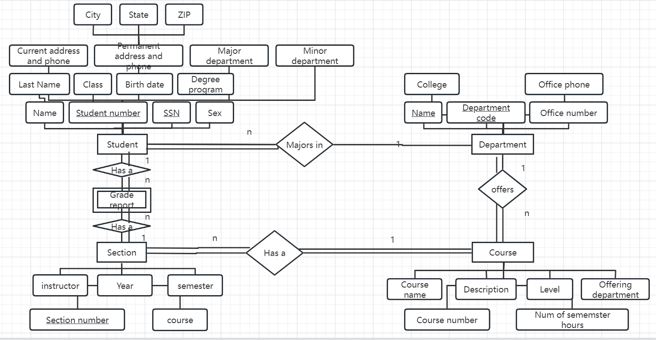

2. Consider the ER diagram in the file named “BANK database ER Diagram.” Each bank can have multiple branches, and each branch can have multiple accounts and loans.

a) List the (nonweak) entity types in the ER diagram

BANK, ACCTS, LOANS, and CUSTOMER

b) Is there a weak entity type? If so, give its name, partial key, and identifying relationship. name: BANK_BRANCH

partial_key: BANK.Code, BANK_BRANCH.Branch_no

identifying relationship: a BANK_BRANCH is a branch of a BANK

c) What constraints do the partial key and the identifying relationship of the weak entity type specify in this diagram?

Each BANK_BRANCH is uniquely identified by a branch_no and a BANK Code.

Each Bank Branch is a Branch of exactly 1 BANK.